ELEC – 310

MICROELECTRONIC CIRCUITS AND DEVICES

TERM PROJECT

LIE DETECTOR

03.01.2022

Mehmet ÇUHADAR – 0068835

Kerem GIRENES – 0069671

Table of Contents

Introduction 1

Technical Specifications 1

Simulation Results 2

Conclusion 4

References 5

List of Figures

*Figure 1: Circuit Diagram with Input Resistance varying between 1k ohm and 1Mega ohm 2*

*Figure 2: Currents through transistors' regions (Negative current indicates direction) 3*

*Figure 3: Current going through the speaker when R = 1 MΩ 4*

*Figure 4: Current going through the speaker when R = 1 kΩ 4*

# Introduction

Aim of this project is to construct a lie detector which works by detecting changing frequencies in a circuit involving BJTs. To design such a device, we utilize two BJT models, BC547 and BC557. We provide input frequencies through holding two open ends of our circuit. We observe our output through an 8-ohm speaker.

We are using our knowledge on PNP and NPN BJTs which we learned throughout the semester. We know that below certain base currents, BJTs are in cut-off region. And we know that above other certain currents, BJTs are in saturation region. We utilize this characteristic of BJTs throughout our project.

Lie detectors are used by national and private security agencies, police departments, and private investigators. They are mostly used with a polygraph. In our project, instead of drawing high amplitude waves, we will be hearing high amplitude sounds.

# Technical Specifications

In order to test if someone is lying, their two hands are placed on two open ends of our circuit. When the suspect is not lying, we have a beeping sound every 3 milliseconds. This is made possible by the capacitor that is between IBQ2 and ICQ1. Therefore, every 3 milliseconds, IBQ2 raises to a level of 14 µA for a short period of time, allowing a current of 2 mA to pass through from ICQ2 (IBQ2) to IEQ2. This in turn allows for a current of 200 mA to pass through from IEQ1 to ICQ1, which goes through the speaker to produce the beeping sound.

With higher resistance between the open ends of the circuit, in 2 of the 3 milliseconds, we observe lower currents in IBQ1, IBQ2, and IEQ2. Thus, we observe a lower currentin ICQ2, which travels through the speaker and does not produce a sound.

When the suspect gets sweaty, the resistance between open ends is lower. Therefore, IBQ1, IBQ2, and IEQ2 are higher. This results in higher ICQ2 that goes through the 8-ohm speaker, producing a high amplitude, continuous sound.

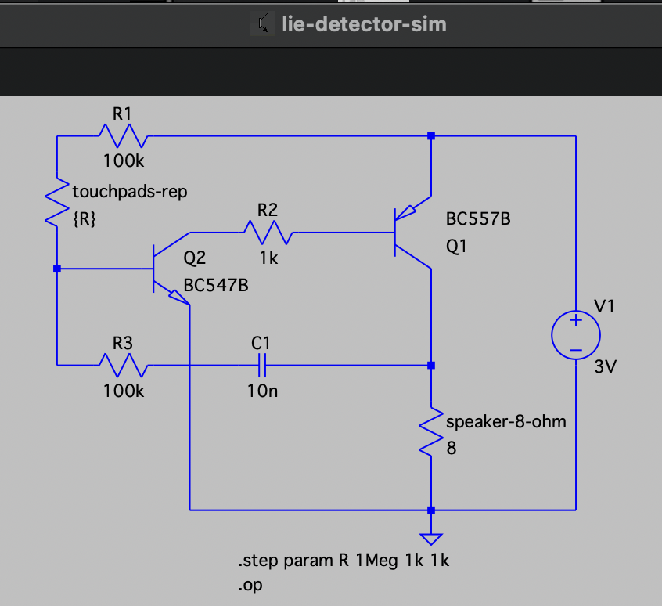

Figure 1: Circuit Diagram with Input Resistance varying between 1k ohm and 1Mega ohm

Following is the SPICE Netlist Representation of the circuit. ASC files are also submitted alongside this report.

R1 N002 N001 100k

R2 N004 N003 1k

R3 N006 N005 100k

C1 N007 N006 10n

Q2 N003 N005 0 0 BC547B

Q1 N007 N004 N002 0 BC557B

V1 N002 0 3V

R§speaker-8-ohm N007 0 8

R§touchpads-rep N001 N005 {R}

.model NPN NPN

.model PNP PNP

.lib /Users/keremgirenes/Library/Application Support/LTspice/lib/cmp/standard.bjt

.op

.step param R 1Meg 1k 1k

.backanno

.end

# Simulation Results

To simulate dry and sweaty hands, we step the R parameter from 1 MΩ to 1 kΩ.

At Rtouchpad = 1 MΩ, we observe the following:

* IBQ2 = 2 µA
* IBQ1 = ICQ2 = 0.6 mA
* IEQ2 = 0.602 mA
* ICQ1 = 100 mA
* IEQ1 = 100.598 mA

At Rtouchpad = 1 kΩ, we observe the following:

* IBQ2 = 24 µA
* IBQ1 = ICQ2 = 2 mA
* IEQ2 = 2.024 mA
* ICQ1 = 196.5 mA
* IEQ1 = 198.524 mA

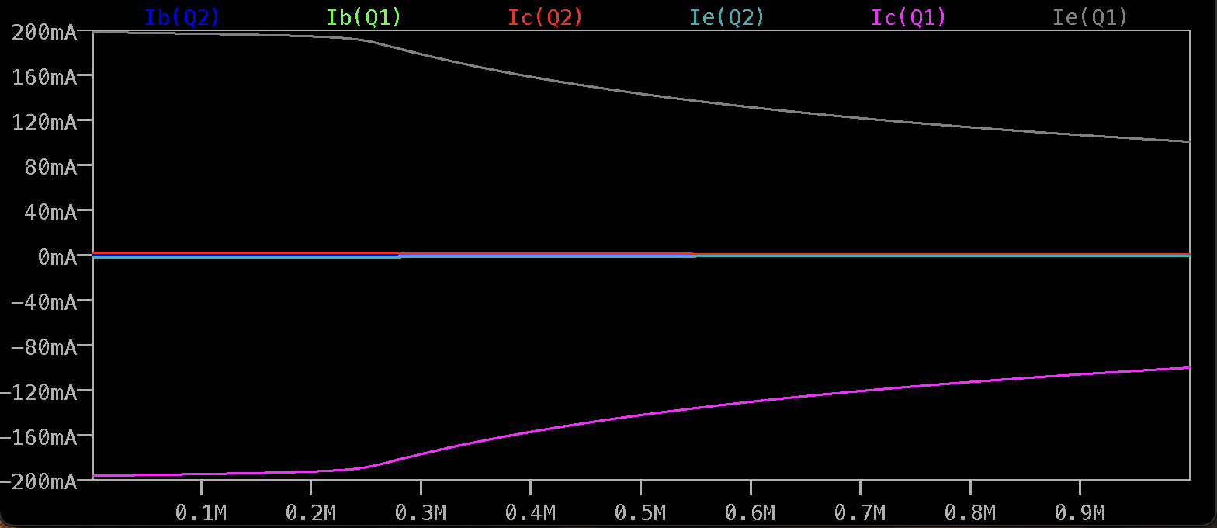

Figure 2: Currents through transistors' regions (Negative current indicates direction)

To observe the beeping sound, we set R to 1 MΩ. The following figure illustrates the current going through the speaker.

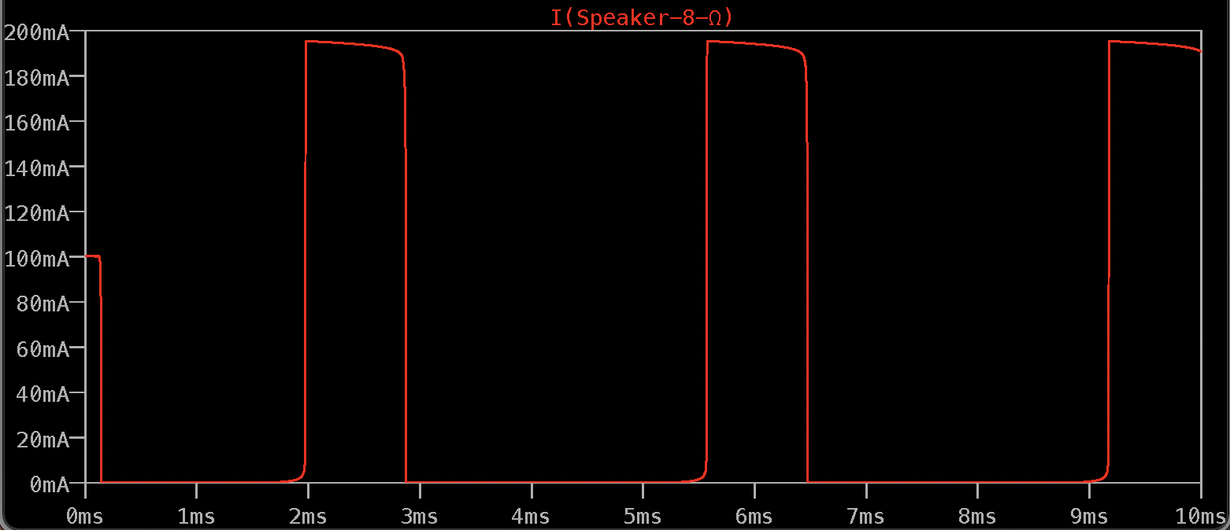

Figure 3: Current going through the speaker when R = 1 MΩ

To observe the continuous sound, we set R to 1 kΩ. The following figure illustrates the current going through the speaker.

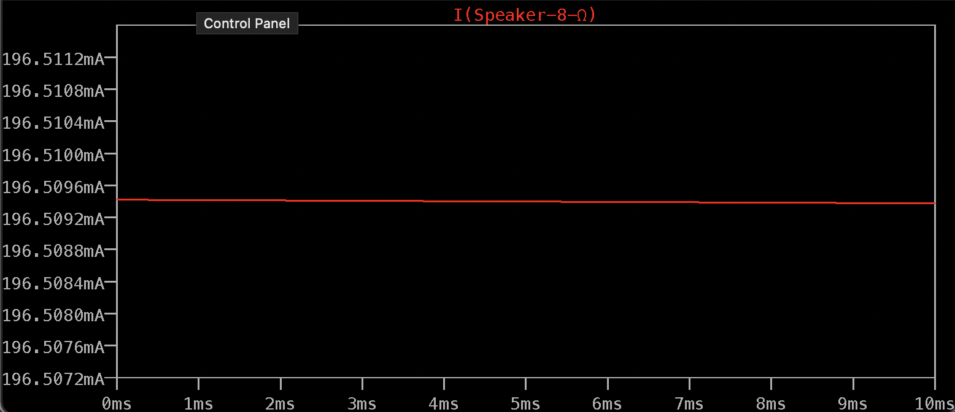

Figure 4: Current going through the speaker when R = 1 kΩ

# Conclusion

Simulation results were as expected. We observed high continuous currents in lower resistances, which would produce high amplitude continuous sounds in real life using a speaker. We had the chance to see two BJTs, one PNP and one NPN, having one’s Base and other’s Collector on the same current line, in action. Moreover, we saw how capacitors can be used with transistors to produce alternating or intermittent signals.

# References